INVITATION AUTO-NAVIGATION
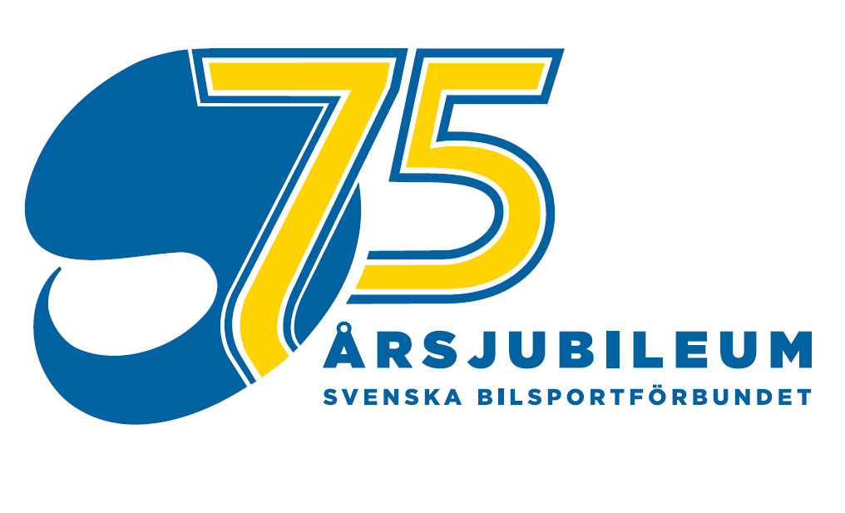
SJÖSLAGET
Saturday 20 August 2011
NEZ-4 ,SM-1

is pleased to invite to the 4th race in the North European Zone (NEZ) Championship, the 1st race in the Swedish Championship (SM) in Autonavigation and included in the Bil-O Syd in Autonavigation on Saturday August 20

The competition is organised in full compliance with Swedish ASN (SBF) national regulations,
The NEZ regulations, SBF:s SM (Swedish Championship) regulations these supplementary regulations and additional bulletins to be issued. For participants in Bil-O Syd Championship the regulations Bil-O Syd Championship apply in addition.

Organiser Wäxjö MS
Clerk of the Course Åke Jansson
Dep. Clerk of the Course Torsten Cordes
Secretary of the meeting Anders Wiktorsson
Dep. Sec. of the meeting Finn Stenström
Organisation committee Rolf Linde, Åke Jansson, Torsten Cordes, Anders Wiktorsson, Ingvar Johnsson, Peter Åhman, Gunnar Holmgren, Mats-Olof Bengtsson, Torbjörn Johansson.
Stewards of the meeting:
Chairman of the meeting Jonas Öhman, Vara MK + 46 70 580 51 15
Steward t.b.a. in PM
NEZ steward Rolf Felin SF
Race Supervisor Folke Ringberg
Chief Scrutineer Mats Svensson

Environment Officer Per Ola Hårdh

Event type Bil-O Type B (non-numbered controls)
Classes NEZ-U, NEZ-S, NEZ-Beginners Cup, SM - All Swedish participants with valid license will automatically participate in SM.
Special class for Bil-O Syd Championship.
Route Common for NEZ, SM. The route for NEZ Beginners-Cup and Bil-O Syd are shorter.
Route Manager Rolf Linde
Total length: apox.120 km with a 30 minutes break included in accordance with NEZ regulations. NEZ-B and Bil-O Syd aprox 80 km,
Navigation stages 9 stages length ca 75 km NEZ-Beginners and Bil-O Syd ABC 6 stages total length aprox 55 km.
Controls TK (time), PK (pass-by), SPK (Sportident PK), BPK (manned), IK (information), and OK (navigation) controls. All IK are drive-through in accordance with the Bil-O regulations. The aprox. numbers of controls will be advised in PM.
Road Book Information given in cross-ruled format
Scales on maps 1:50 000, 1:25 000, 1:15 000, 1:10 000, 1:5 000, 1:3 000 1:2 000, 1:1 000 - some in own production.
Time keeping Sport Ident, sticks are available for the event and can be lent. Lost stick will be charged 250 SEK. Additional info please refer to www.sportident.se (also in English). Instructions for Sportident system will be available at Start.
Delay time Advised in PM

Entry Fee SEK 800;- for SM/NEZ.
SEK 450:- Bil-O Syd ABC.
The fee is paid on reporting at the HQ on September 26. Late entry adds 150 SEK to the fee.
NEZ-Beginners: NEZ Beginners Cup in accordance with the NEZ-regulations. Participants in NEZ Cup can decide at the break to drive the complete NEZ route.

Head Quarters Hovmantorp Folkets Hus 25 km east of Växjö by road Nr 25
Approximate distance from Stockholm 510 km, Malmö 270 km Göteborg 310 km, Karlskrona 100 km. www.route.rac.co.uk or www.hitta.se
Starting List and PM will be announced on www.bil-o.se
Starting order NEZ-regulations take priority followed by the SM regulations and finally the regulations for Bil-O Syd Championship.
First start 17.00 (approved by NEZ Committee)
Registration Latest 1 hour prior to your starting time
Scrutineering Prior to reporting, location advised in PM
Equipment According to Bil-O 8.5.1, non-Swedish participants in accordance with their national regulations.
Insurance According to SBF G6, that is, in accordance with the insurance policy of each participant.

Entry Identify clearly to which event you apply, NEZ-U, NEZ-S, NEZ Beginners Cup, SM and Bil-O Syd ABC.
Entry date Monday 15 August via Internet, www.bil-o.se

Results & Prizegiving Final results posted at HQ (NEZ-U, NEZ-S, NEZ Beginners Cup, SM, Bil-O Syd serien at the expiry of the protest time and the completion of the event. Award ceremony to be followed immediately there after. Award ceremony for pre-event Dackenatten 19/8 prior to driver meeting.
National Team For NEZ according to NEZ regulations 2011

Car import Participants from a non-EU country are advised to contact the Swedish Custom Authority to ensure compliance with the applicable rules.
Contact Tullverket (Swedish Customs Authority) at an early stage on phone +46 771-23 23 23 or www.tullverket.se to obtain the correct information on applicable rules and regulations.

Pre-Event Wäxjö MS jointly with Grimslöv MS and Älmhult MK (approx. 40 km south of Växjö) organises an NEZ Auto-Navigation-3 on Friday 20 May Information and application on www.bil-o.se

PUL By signing the entry form you accept that the organiser can publish your (Law Personal Information) name in Start and Result lists on the Internet.

Further information Torsten Cordes/SE-DK-ENG
torsten@cordes.se +46 478 41016, +46 70 363 9511

Cancellation The Clerk of the Course reserve the right to cancel the event at force majeure or for any other accepted reason. If so info will be send to all competitors.
Miscellaneous PM, starting list and results will be published on the Internet, www.bil-o.se
Responsibility The competitors take part on their on risk. The FIA, the Swedish ASN, the organiser or officials of the event can not accept any responsible or liability for injuries to persons and/or property occuring during the competition.

Växjö MS is pleased to welcome you to Växjö/Hovmantorp and the NEZ-4 and

SM-1 Auto-Navigation competition.

Lodging Grimslöv
Grimslövs Värdshus (8 rooms)
Phone +46 70 369 9558
Fax +46 470 750641
www.hotellboka.se

Torne Camping
Phone +46 470 754120
www.tornecamping.com

Hovmantorp

Camping with 7 cabins (with kitchenette), 4 with 4 beds, and 3 with 6 beds sand campersites with power outlet (220 V/50 Hz).
Phone +46 47 84 08 07
www.camping.se/g11, gokaskrattscamping@telia.com

Folkets hus (B&B) 5 twin bed rooms and 1 room with 4 beds
Telefon +46 47 84 20 45
www.folketshuset.se mail: folkets.hus@passagen.se

Motel Glasblåsaren offers 13 beds.
Telefon +46 47 84 05 95
www.glasblasaren.se mail: info@glasblasaren.se

Bergdala Wärdhus +46 478 18030
www.bergdala.com

Växjö can offer of Hotels, below you find some examples

Scandic Hotell +46 470 736000
www.scandichotels.com

Toftastrand Hotell +46 470 65290
www.toftastrand.nu

Tourism Pls check out www.glasriket.se for information on the famous Swedish glass mills located in the close vicinity of Hovmantorp.

